Research Report

1. Research question

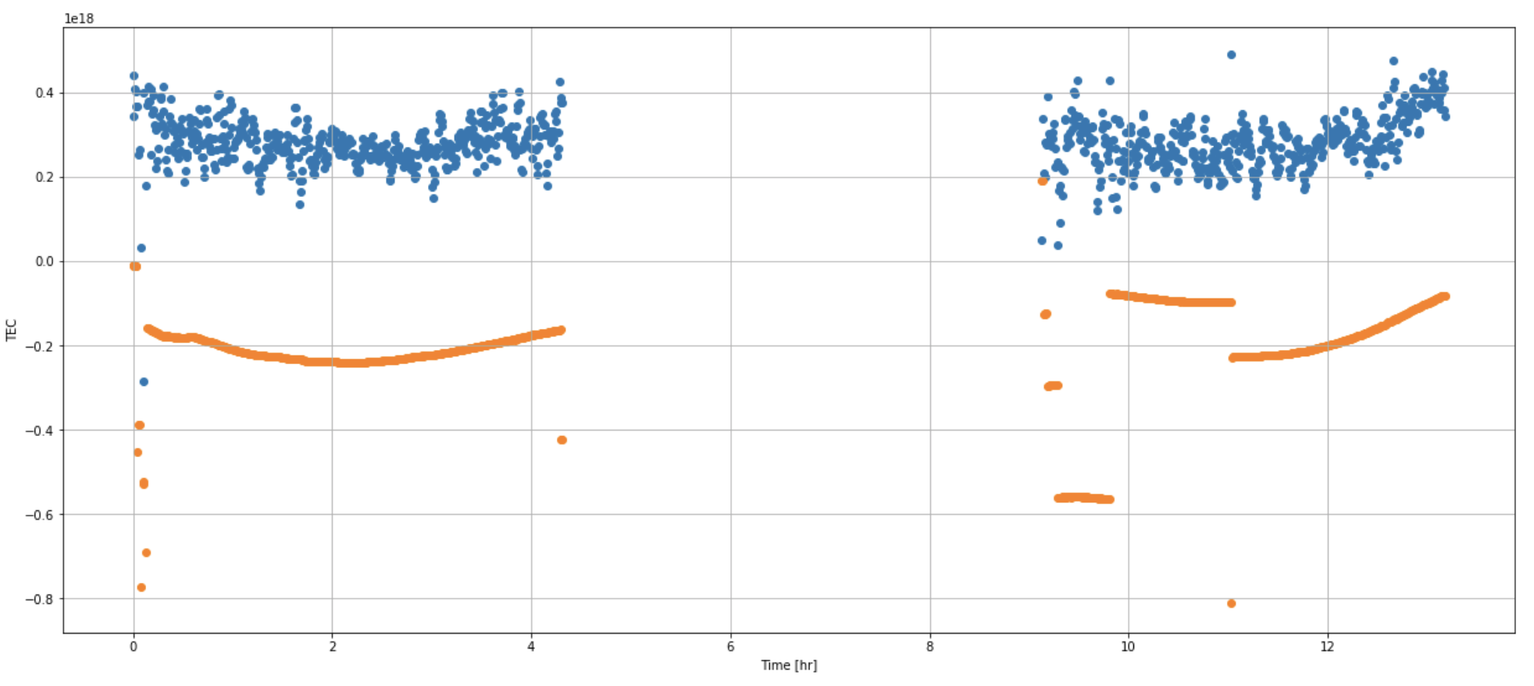

The orange line is the TEC line, we want to know what factors caused the jumps points in this picture. And we would like to produce few small question in the future if we can.

1. Research tools

In this research tools, we would like to use jupyter notebook, observation data from the NASA, which is open. And plot data file

1. Techniques

When we finish the data plot, and get a few conclusion, we would like to use machine learning to analyze the results.

1. Research plan

In this research, we would like to use machine learning to analyze the data. First, we will use plot data file to see the TEC line difference. We need at least five years file per day to see the difference and use the background information to guess or draw a basic conclusion what causes these jump point in the TEC line. And then, we would like to use the machine learning to see what happened and what factors caused these issues.